TERMS OF USE
AMM's Simulated Strategies Hub™
Cryptotized Gameplay™
Effective Date: July 2026
Version: 1.0

1. Welcome
Welcome to AMM's Simulated Strategies Hub™ ("the Platform").
These Terms of Use govern your access to and use of all guides, documentation, templates, community submissions, website content, GitHub repositories, and related materials created by Angel Mendez ("AMM").
By accessing or using these materials, you agree to these Terms.

2. Purpose
Cryptotized Gameplay™ is a fan-created educational and entertainment framework designed to encourage strategic thinking, creative roleplaying, and simulated decision-making.
It is not affiliated with, endorsed by, sponsored by, or approved by any game developer, publisher, platform owner, or AI provider unless expressly stated.

3. Intellectual Property
Unless otherwise noted, all original content—including but not limited to:
- Guides
- Rule systems
- Written documentation
- Original artwork commissioned or created for the project
- Logos
- Branding
- Website content
- Graphics
- Templates
- Original mechanics
is the intellectual property of Angel Mendez and AMM's Simulated Strategies Hub™.
All Rights Reserved.
Game titles, characters, logos, artwork, trademarks, and other third-party intellectual property remain the property of their respective owners.

4. Personal Use
You may:
- Read the guides.
- Download the guides for personal use.
- Use the guides while playing legally obtained copies of supported games.
- Share links to the official website or GitHub repository.
- Submit original community-created guides for review.

5. Restrictions
You may not:
- Sell official guides without written permission.
- Redistribute official guides as your own work.
- Remove copyright notices.
- Remove author credits.
- Claim ownership of Cryptotized Gameplay™.
- Impersonate AMM's Simulated Strategies Hub™.
- Use official branding in a manner that suggests endorsement.

6. Community Contributions
Community members may submit original content for consideration.
By submitting content, you confirm that:
- You created the work yourself or have permission to submit it.
- The work does not infringe another person's intellectual property rights.
- You grant AMM's Simulated Strategies Hub™ a non-exclusive, worldwide, royalty-free license to review, edit, publish, display, and distribute the submitted content if accepted.
Authors will be credited whenever reasonably possible.
You retain ownership of your original submission unless you separately agree otherwise.

7. AI Content
Cryptotized Gameplay™ may incorporate AI-generated text, ideas, simulations, or artwork.
AI-generated content may contain mistakes.
Users should independently verify important information before relying upon it.
Never share sensitive personal, financial, or confidential information with AI systems.

8. Financial Simulation Disclaimer
Any references to:
- Cryptocurrency
- Digital assets
- Simulated tokenization
- Paper trading
- Investing
- Market prices
are provided solely for educational and entertainment purposes.
Nothing contained within Cryptotized Gameplay™ constitutes financial, investment, tax, accounting, or legal advice.
Always perform your own research before making real-world financial decisions.

9. No Piracy
This project does not encourage piracy.
Users should only play games they legally own.
Please support the developers and publishers who created the games that inspire these guides.

10. Third-Party Services
This project may reference third-party services including AI platforms, GitHub, websites, or other software.
AMM's Simulated Strategies Hub™ is not responsible for the availability, security, policies, or accuracy of third-party services.

11. Disclaimer of Warranties
Cryptotized Gameplay™ is provided "AS IS" and "AS AVAILABLE" without warranties of any kind, express or implied.
We do not guarantee that the guides will be free of errors or suitable for every user's circumstances.

12. Limitation of Liability
To the fullest extent permitted by law, Angel Mendez and AMM's Simulated Strategies Hub™ shall not be liable for any direct, indirect, incidental, consequential, or special damages arising from the use of this project.
Use of the guides is entirely at your own risk.

13. Changes
These Terms may be updated periodically.
The latest version will always be published through the official website or GitHub repository.

14. Contact
Questions regarding these Terms may be directed to:
Angel Mendez
AMM's Simulated Strategies Hub™
Email: contact@ammstrategieshub.com

15. Copyright
Copyright © 2026 Angel Mendez
AMM's Simulated Strategies Hub™
All Rights Reserved.

# Find me on your favorite platforms #

GitHub: https://github.com/AMMs-Simulated-Strategies-Hub

X-Twitter:
https://x.com/AMMsSimStrategy

Instagram:
https://www.instagram.com/ammssimulatedstrategieshub?igsh=MXEyYmhyZnpxYzRlZg==

The End

In the future, I hope my website and community will become the next GitHub for roleplaying research and development.

Thank you for participating, please feel free to leave feedback on my platforms!

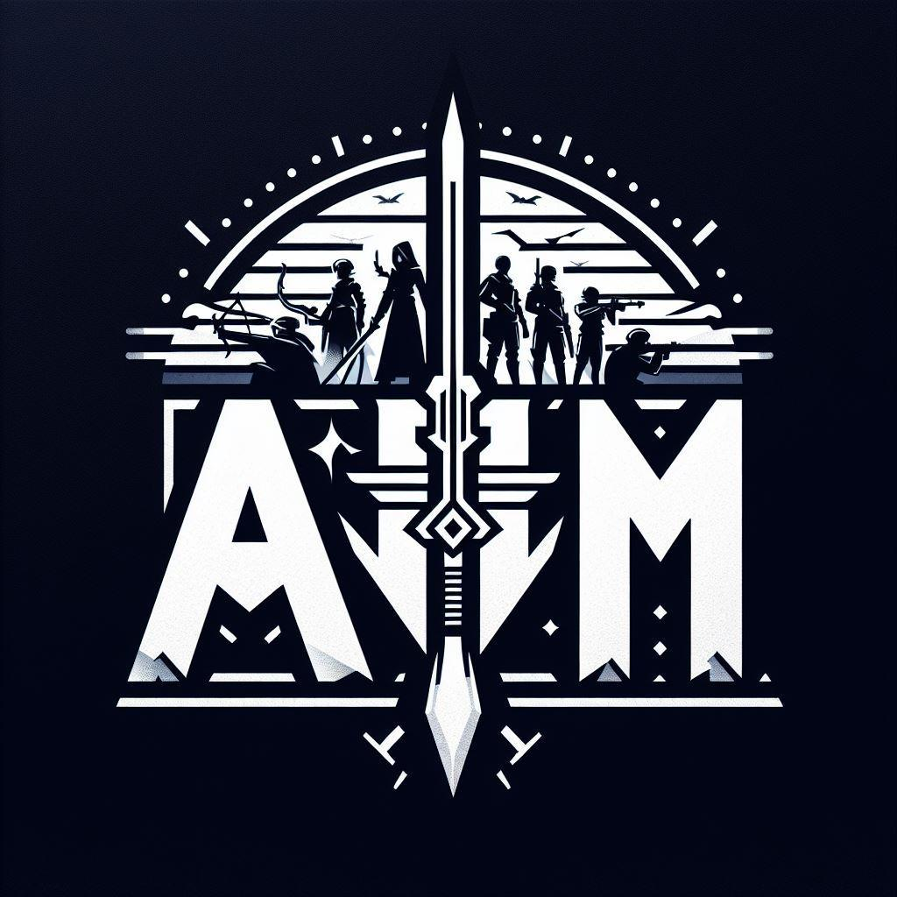

AMM's Simulated Strategies Hub™
Copyright © 2026 Angel Mendez. All Rights Reserved.

